**Deploy Hello-World Application with Spring Boot and RestAPI**

**2021/08/11**

This document describes process of a simple “Hello world” application using Spring Boot and Rest API

IntelliJ IDEA: <https://spring.io/guides/gs/intellij-idea/>

JDK 1.8 or later

Maven 3.2+

GitHub Code: <https://github.com/ahmadrathore/SpringBoot_HelloWorld.git>

The following processes describes the steps to generate a web application using Spring Boot framework.

1. Generate a new project with the required dependencies

Visit the *Spring Initializr* (https://start.spring.io/) to generate a new project with the required dependencies (Spring Web).

Select option Project->Maven Project, Spring Boot->2.5.3 V and write name in project MetaData.

Select dependencies of Spring Boot DevTools, Thymeleaf and Spring Web

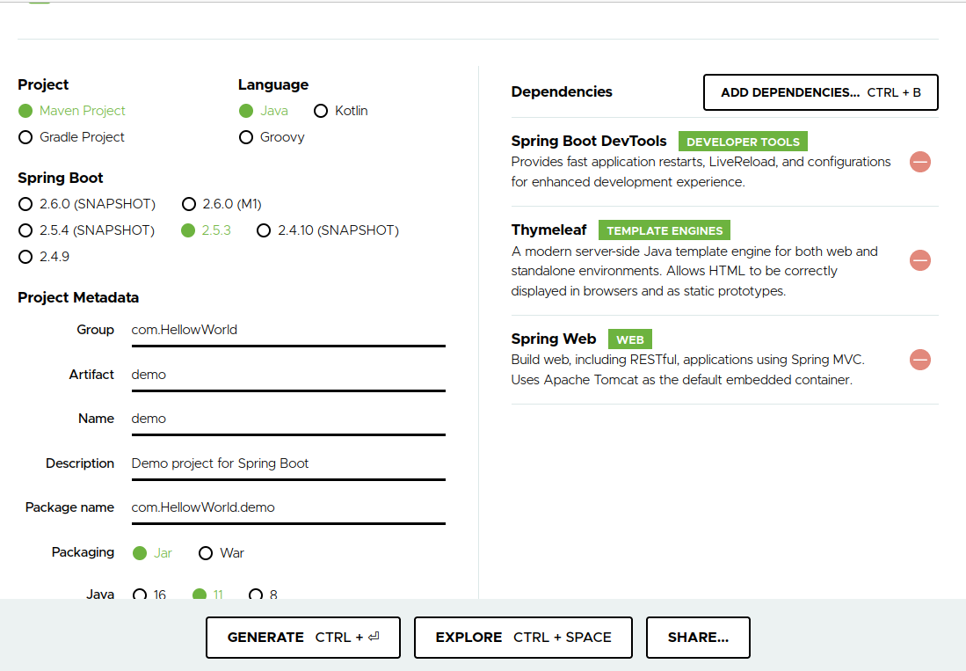

Click on generate and extract the executed zip file.

1. We used IntelliJ IDEA for development. Select file-> New-> Project from Existing Sources and click the extracted folder.

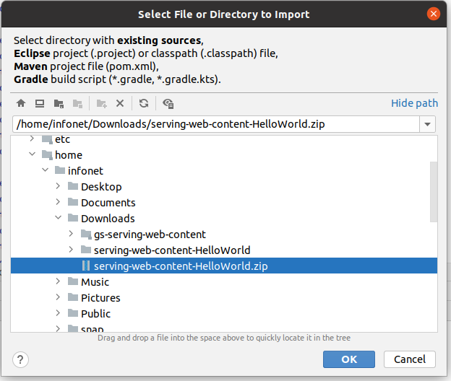

In the File-> Project structure, choose Project SDK and select openjdk-16 version.

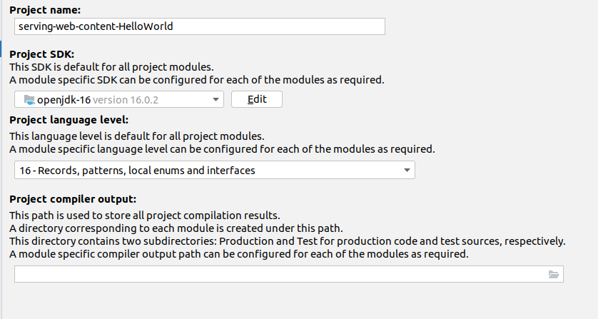

1. Write a Web Application

To handle web request create a java file “HelloController.java” in src/main/java/com/HelloWorld/servingwebcontent/

*package com.HelloWorld.servingwebcontent;*

*import org.springframework.web.bind.annotation.GetMapping;*

*import org.springframework.web.bind.annotation.RestController;*

*@RestController*

*public class HelloController {*

*@GetMapping("/")*

*public String index() {*

*return "Greetings from Spring Boot!";*

*}*

*}*

The class is flagged as a @RestController, meaning it is ready for use by Spring MVC to handle web requests.

1. Create an Application Class

Modify the the Spring Initializer class created to match the following listing (from src/main/java/com/HelloWorld/servingwebcontent/ servingwebcontentApplication.java):

*package com.HelloWorld.servingwebcontent;*

*import org.springframework.web.bind.annotation.GetMapping;*

*import org.springframework.web.bind.annotation.RestController;*

*@RestController*

*public class HelloController {*

*@GetMapping("/")*

*public String index() {*

*return "Greetings from Spring Boot!";*

*}*

*}*

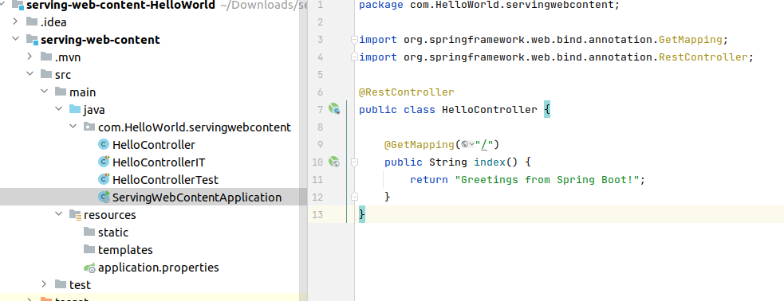

1. Run the Application

To run the application, right click on the ServingWebContentApplication.java and click run.

We can also run *./mvnw spring-boot:run* command in the terminal.

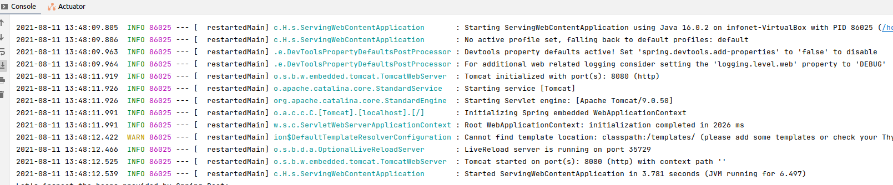

To verify on the terminal write command

url localhost:8080

On the browser write command

localhost:8080

